**shutter-control-2.vi**

This VI controls the camera and laser shutters as well as the filter wheel speed. Control of camera shutter is separate from laser shutter. Whenever a laser shutter selection is made on the front panel, the camera shutter is turned off followed by a 5 ms delay. Without this delay, we found that the hardware did not receive a signal to turn off. All laser shutters are then turned off. The filter wheel is changed according to the selected laser type and filter wheel speed. Depending on the latter, a delay is added for when the selected laser shutter is turned on. The camera is shutter is then turned on, depending on the user’s selection on the front panel. After the aforementioned delay, the laser shutter is turned on. The current wheel position is displayed on the front panel.

SubVIs:

1. Laser Daq - SubVI
   1. Turns on/off shutters when selection is made
2. Generate-Command-SubVI
   1. Generates a command to be sent to the filter wheel via USB.
3. Global Shutter Variables - SubVI
   1. Global string variable indicating the current shutter
4. Initialize-FilterWheel-SubVI
   1. Initializes the filter wheel to be used
5. control-shutter-subvi
   1. Not directly used by main VI
   2. Broadcasts commands to shutter-control-2.vi via user event structures
6. Global Variables
   1. Global Shutter Variables – SubVI
      1. Stores current values in shutter-control-2.vi
   2. shutter-user-event-out-global
      1. User event cluster which is necessary for user event functions

This vi controls/activates the laser shutters.

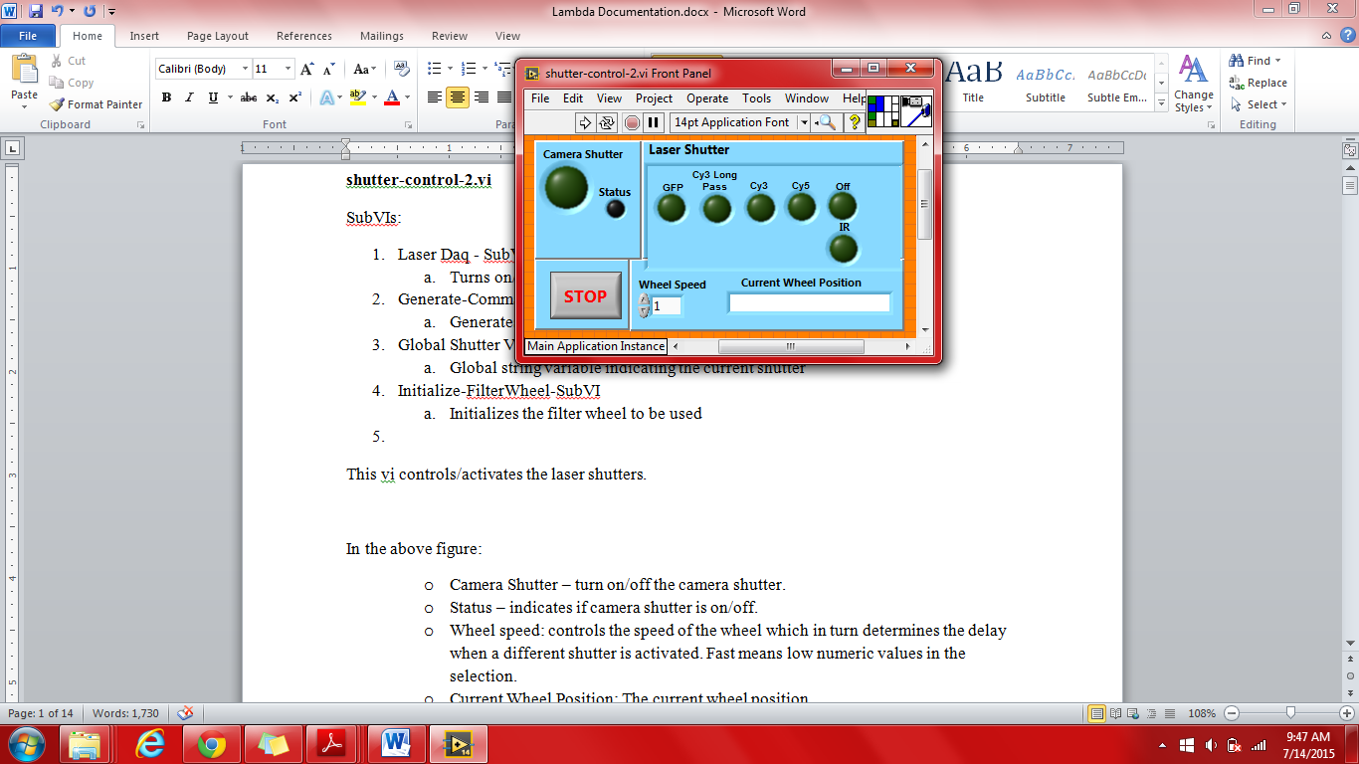

In the above figure:

* + Camera Shutter – turn on/off the camera shutter.
  + Status – indicates if camera shutter is on/off.
  + Wheel speed: controls the speed of the wheel which in turn determines the delay when a different shutter is activated. Fast means low numeric values in the selection.
  + Current Wheel Position: The current wheel position
  + Laser Shutter
    - GFP: 488nm Band Pass
    - Cy3: 532 nm Notch Filter
    - Cy3: 532 nm Long Pass
    - Cy5: 637 nm Notch Filter
    - IR: Infared Laser shutter – same as GFP
    - Off: turns off both camera and laser shutters
  + Stop – terminates the program

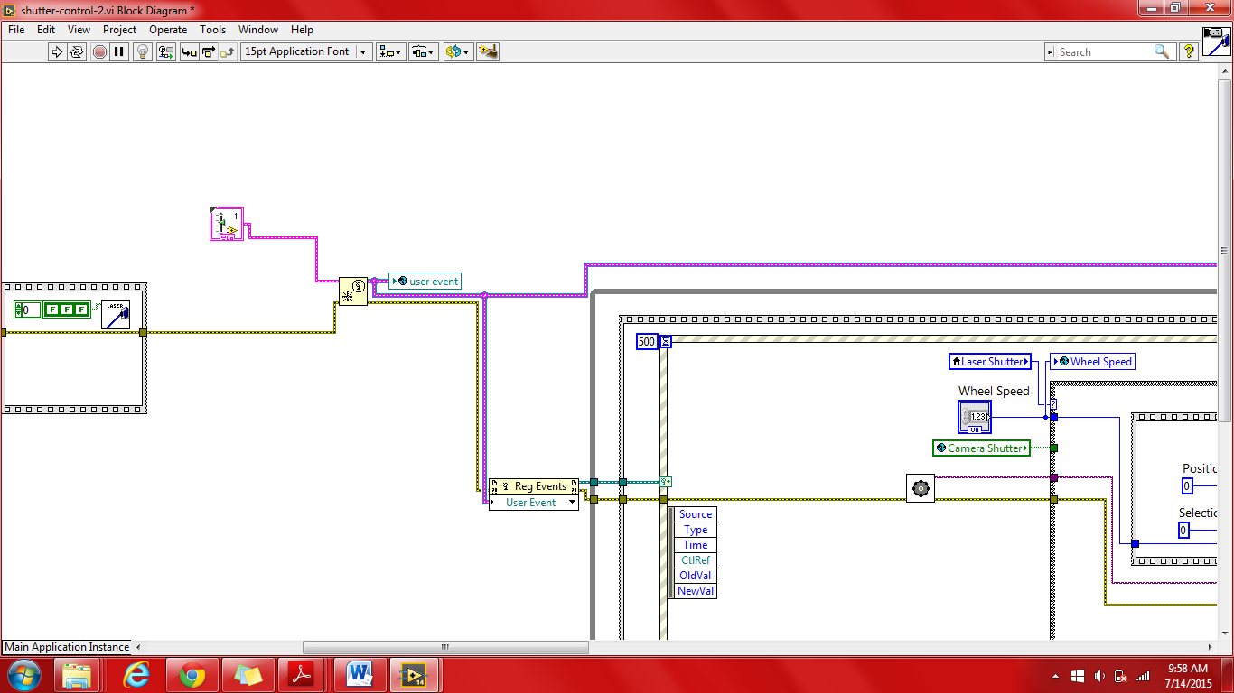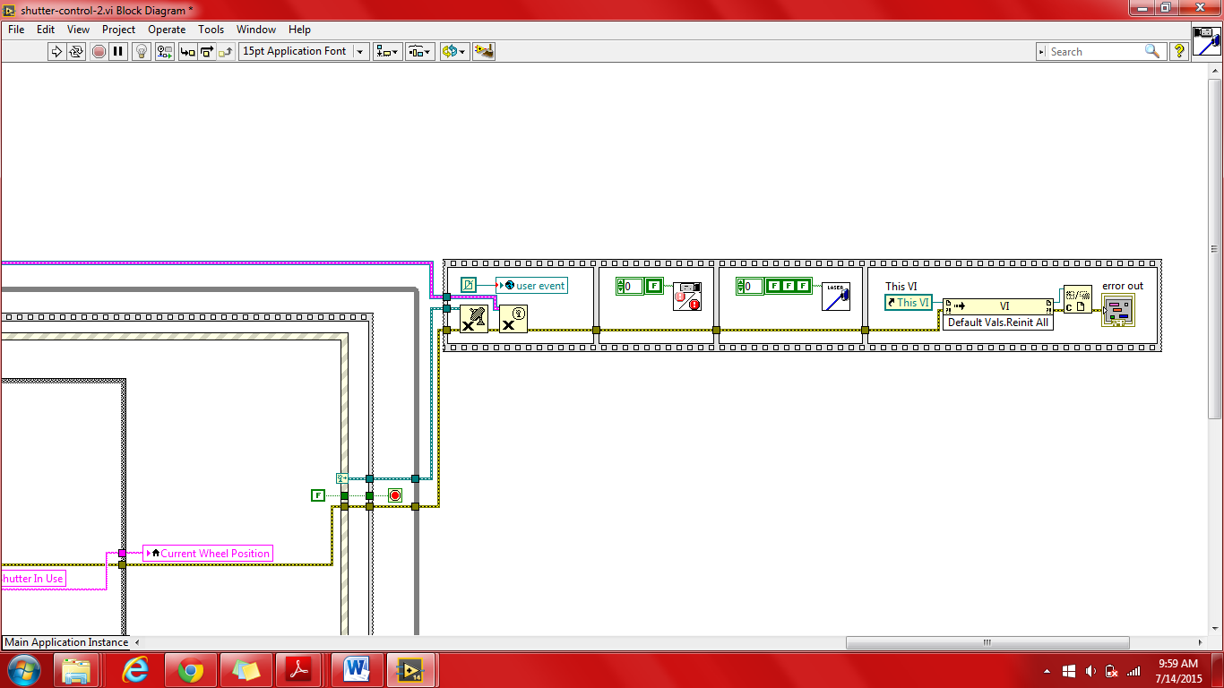

In the above figure:

Changes made in control-shutter-subvi.vi from other VI’s (which require interface with shutter-control) are broadcasted in to shutter-control-2.vi via the functions above.

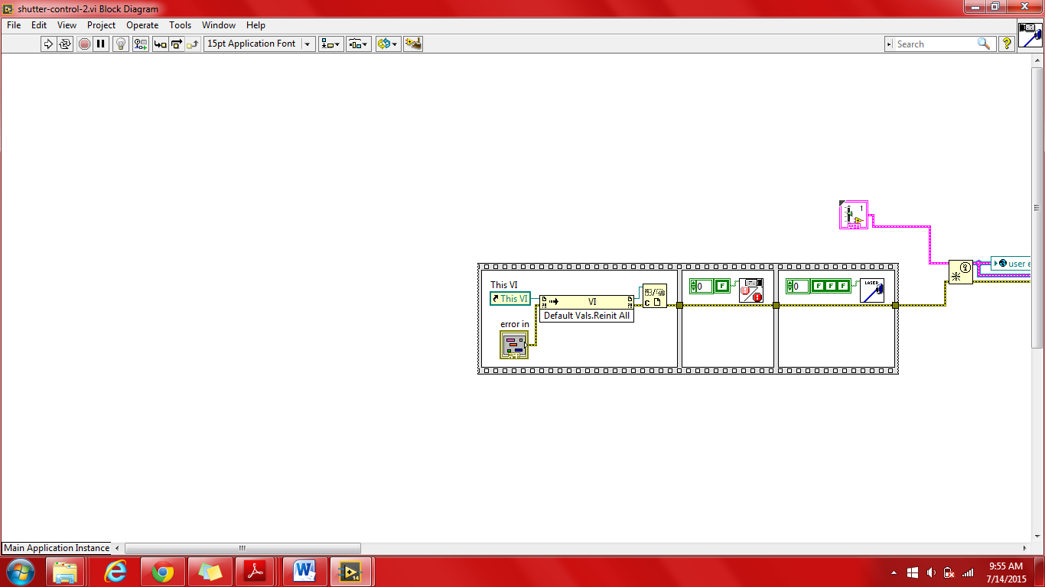

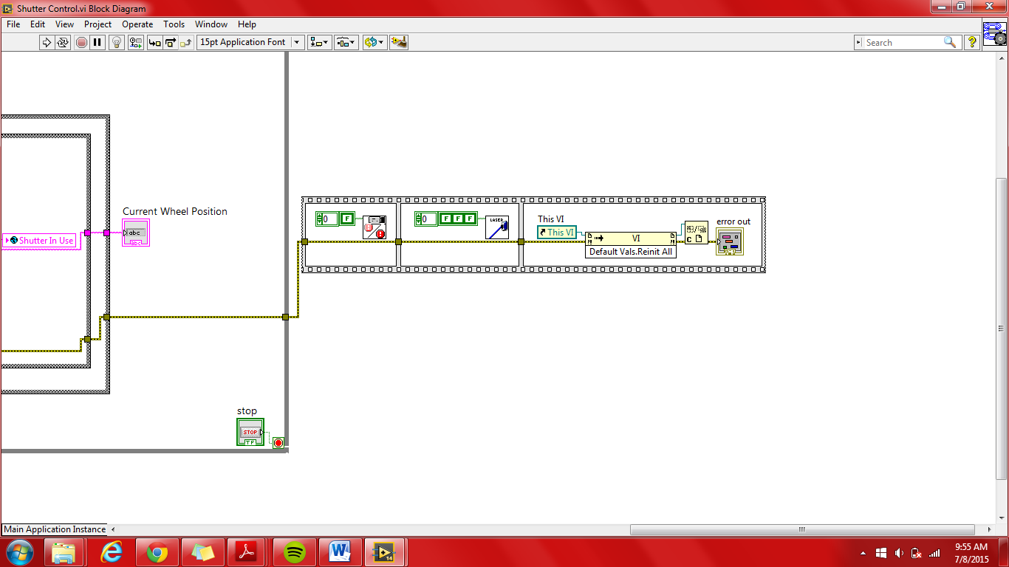

In the above figures:

At the start and end of the program, the two sequence structures shown above turns off all shutters and reinitializes all values to default, i.e. the program turns off the camera shutter and laser shutters.

**stage-controller.vi**

This vi adjusts the stage’s position according to the user’s specifications. A plot for the x & y axis is shown as well as a slide plot for the z-axis. The values of the axis can be incremented simply by clicking on one of the 6 arrow buttons or, in the case of the z-axis sliders, sliding the bar to their desired value. The value of the increment may be adjusted for the X and Y in the space below x,y step (um) and for the Z axis, the z step (um) slider. Current axis values and their range are on display. The user is also allowed to select a field size from 1, 4, 9, and 16. The current field size position is highlighted as shown in the figure below. The black button resets the position to the center of the stage while the red stop button quits the user out of the stage controller. Field Number allows the user to center the stage on a particular field. The field numbers increase from bottom to top in a snake like manner.

**\*\*Note:** If it appears that X & Y integer values conflict with their Boolean counterparts know that this was done intentionally as the images obtained from camera acquisition were off by 90°.

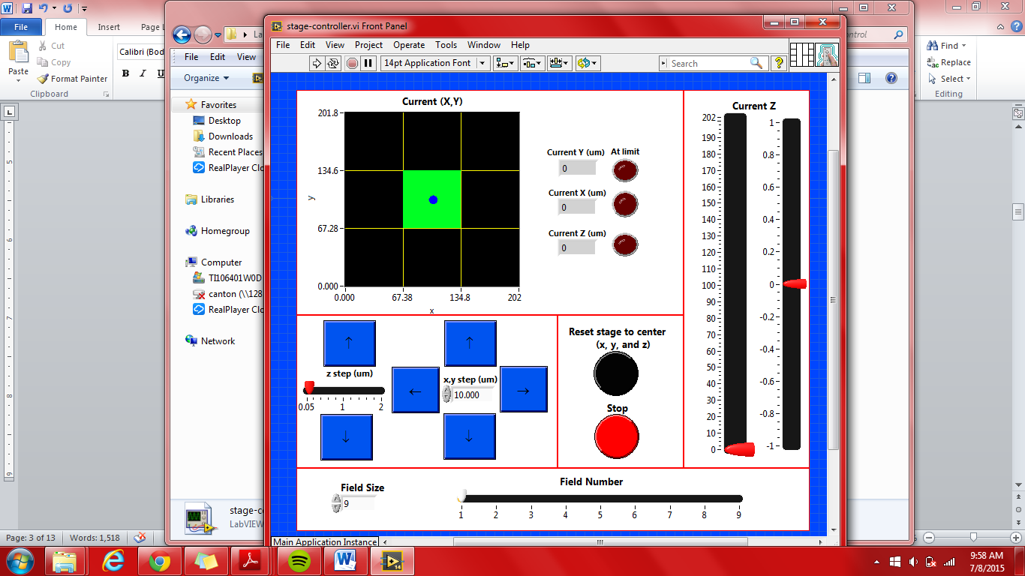

SubVIs:

1. field raster.vi
   1. Determines the X and Y scale markers as well as highlighting the current field position.
   2. Inputs: Xmax (globals), Ymax (globals), field number (from stage-controller.vi), and field size (from stage-controller.vi).
   3. Outputs: current X(center X of field), current Y (center Y of field), x mark (X scale markers), y mark (y scale markers), plot 1 (upper line plot), plot 2 (lower line plot), marker boundary variables (X/Y mark up/down), and surrounding field numbers (XDIF, YDiffUp, and YDiffDown).
2. field-raster-globals.vi
   1. Stores all global variables used in the stage-controller.vi and subvis.
3. Initialize-NanoDrive-SubVI
   1. Initializes the stage/nanodrive
   2. Determines the range of the axis (x,y,& z)
4. Move stage command – Global - SubVI
   1. This vi was taken from the Glimpse VI stage controller
   2. Adjusts the stage depending on the user’s step selection
5. NanoDriveInfo-SubVI
   1. This is actually a subVI of Initialize-NanoDrive-SubVI
   2. Obtains information from the nanodrive/stage
6. Nano-drive-usb-SubVI
   1. This VI was copied from Glimpse stage controller
   2. Outputs the current values of the axis to the nano drive
7. updateFieldnumber – subvi.vi
   1. Is used whenever the field size is altered. This vi ensures that the current position is correctly highlighted by the field raster by outputting the new field number according to the adjusted field size.
8. user event out globals - SubVI
   1. Global variable
   2. Obtained from Glimpse global stage configuration
   3. Important for communicating changes according to the autofocus/tirf lock.

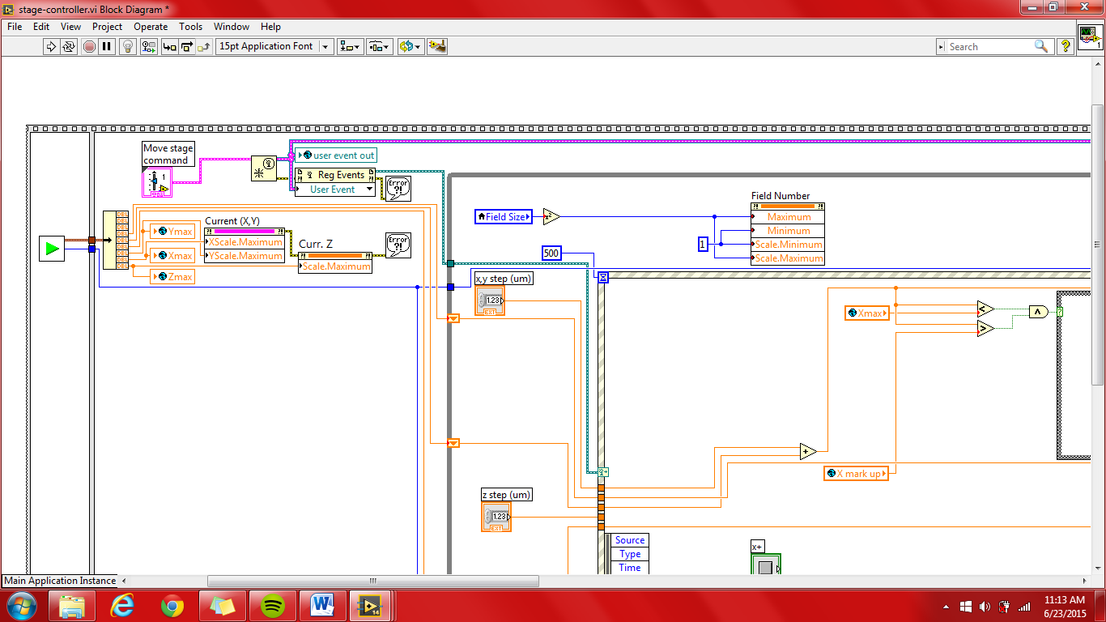

Above Figure:

1. Initialize-NanoDrive-SubVI is shown on the left. It outputs the current (x, y, z) plane and the max values of the (x, y, z) plane. The max values are read to the global max variables as well as to the Current (X,Y) max scales and Z scale.
2. The Move stage command moves the stage according to changes made by other vis which requires collaboration with the Nano positioner. These changes are added to the event structure.

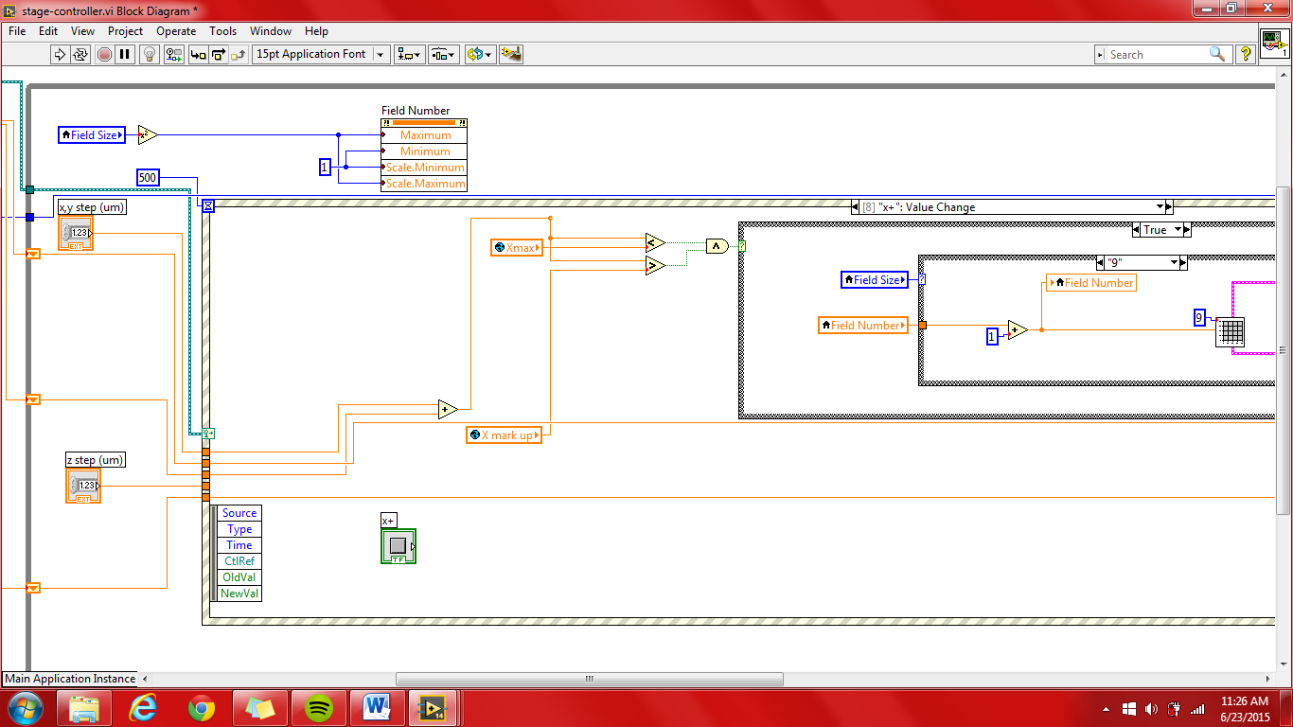

Above Figure:

Changes to the current field size are applied to the field number scroll (ex) Field size = 16, Field Number = 1-16). The current (x, y, z) plane positions and step values ( x,y step and z step) are used as inputs to the event structure shown above. An event structure is synonymous with its name: it performs the functions in each case according to changes that occur on the front panel, i.e. a Boolean is altered. Altogether, the event structure has 13 cases, each case responsible for performing a function according to a specific change on the front panel.

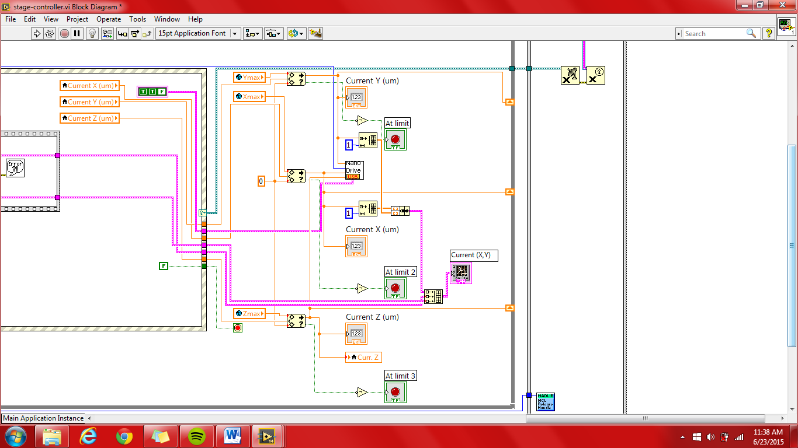

Above Figure:

Changes to the current (x, y, z) plane are applied to the Current (X, Y) and Current Z graphs. The Vi in the center of the image shown, Nano Drive USB, is responsible for implementing the changes to the plane.

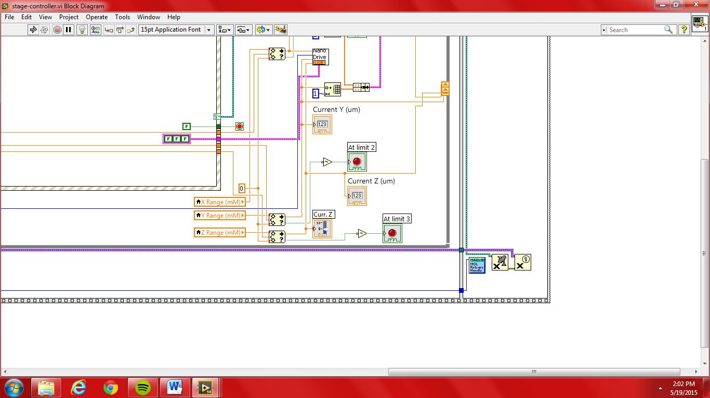

In the above figure:

The handle value from Initialize-NanoDrive-SubVI is sent to the mad city library function, release all handle. The other two functions are not well understand and were taken from Glimpse along with user event out.

**Camera Image Acquisition.vi**

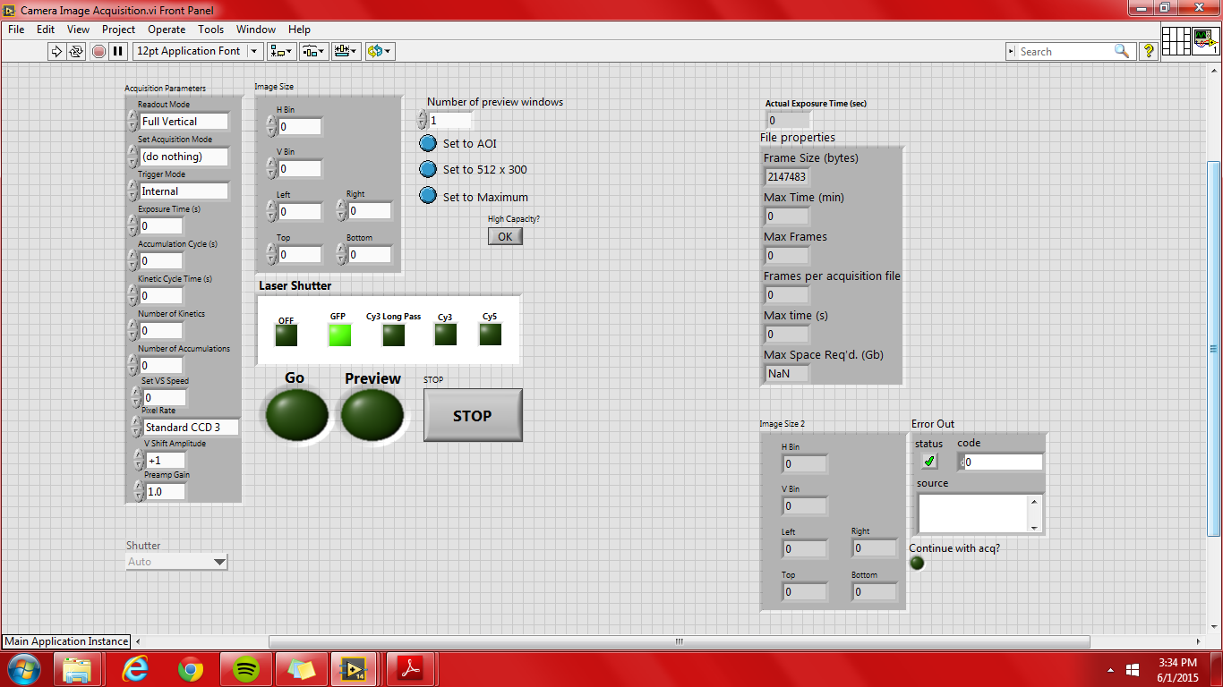

This VI is found within camera test folder of Lambda Testing. The purpose of this VI is to acquire an image(s) during the live feed while a laser(s) is turned on.

**\*VERY IMPORTANT\*** Make sure that the settings are adjusted to your specifications prior to running the VI, especially the Image Size parameters. However, *the Boolean Variables maybe altered whenever* during the VI run.

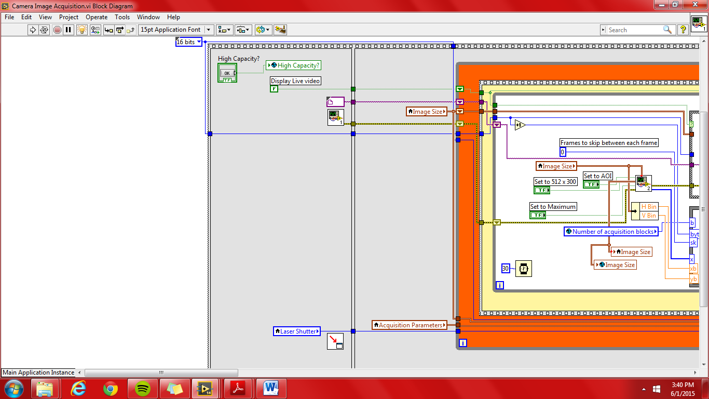

In the above figure:

* + The first event in the program, only ran once.
  + The Boolean High Capacity is accounted for then sent to the Initilize Globals which is subsequently used in Initialize Andor.vi.
  + The Initialize Andor.vi initializes the Andor camera. This only needs to be done once.
  + The Position calling VI to…vi chains the order of VI’s opened during the course of the program’s run.
  + The Laser Shutter local variable outputs the user’s selection of which laser to use.
  + An image file to be used in case of default is ouput to the remaining events. Only used for preview.
  + The display live video Boolean is hardcoded to false. If this should be changed is not understood.
  + The default bit size of the images to be acquired is hardcoded to 16 bits. Although additional bit sizes are listed within the array, only the 8 bit size could possibly work.

**camera-startup.vi**

This VI functions to control the temperature of the Andor camera. This VI should be used prior to performing any acquisition and at the completion of an analysis in order to properly turn off the camera by it to room temperature (~20°C).

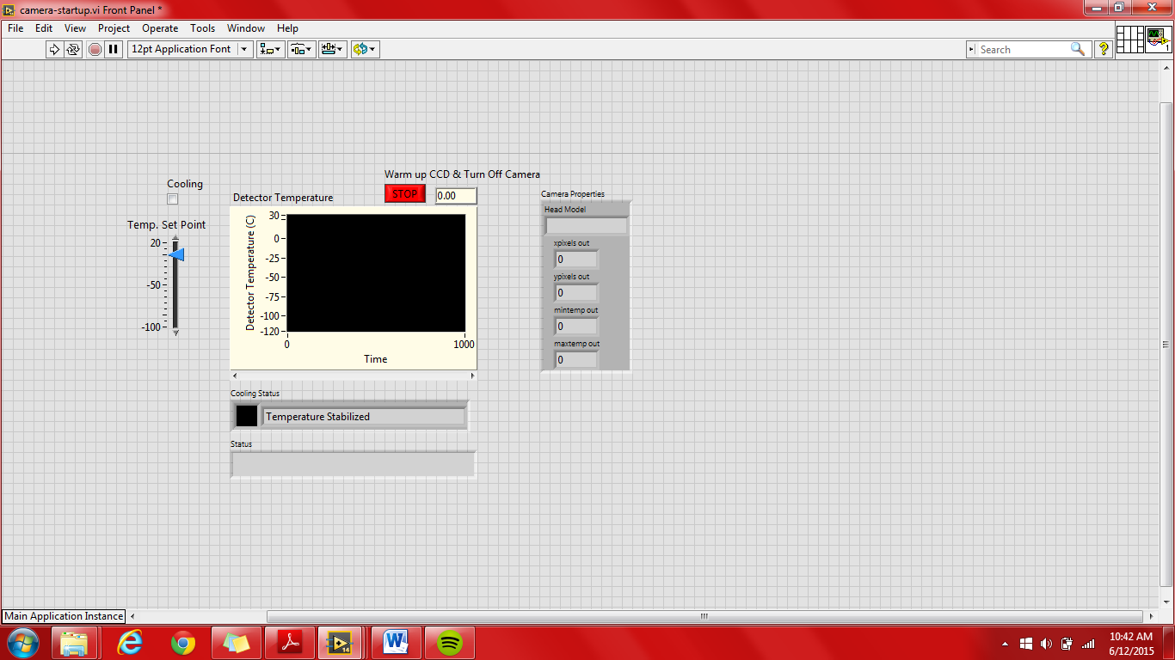

Sub-VI’s:

* Andor Vi’s
  + Cooler On.vi
  + Cooler Off.vi
  + Initialize.vi
  + Shut Down.vi
  + Set Temperature.vi
  + camera stop.vi
* camera-get-info-subi.vi
* get camera temperature.vi

**\*\* Note:** Any values of 20002 within the VI are codes to confirm that the andor vi’s were successfully performed.

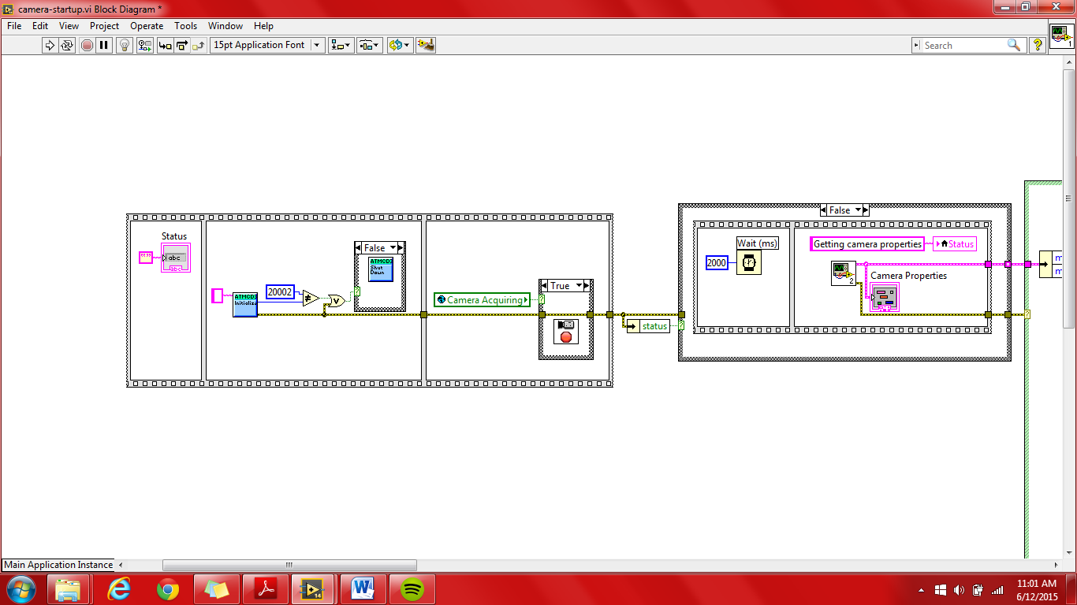

In the above figure:

The Andor camera is first initialized via the *Initialize.vi*. If initialization was unsuccessful for whatever reason, the camera shuts down via the *Shut Down.vi*.

If the global Boolean Camera Acquiring indicates that the camera is already acquiring, then the vi *camera stop.vi* will force it abort acquisition.

In the far right True/False structure, if no error was generated in the previous Vis, there is a 2 second delay prior to the initialization of the *camera-get-info-subvi.vi*. In the camera-get-info-subvi.vi, the Head Model of the camera, X & Y pixel values, and temperature range are obtained. These values are clustered and ouput from the VI. The range from this VI is used to establish the min and max of the Temp. Set Point numeric slide bar and the detector graph as shown in the image below.

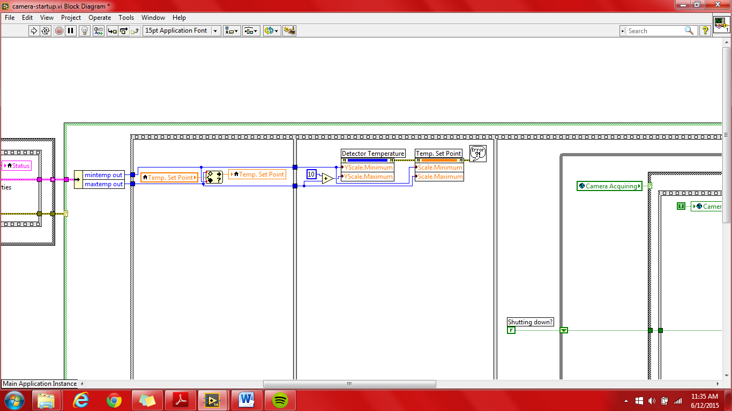

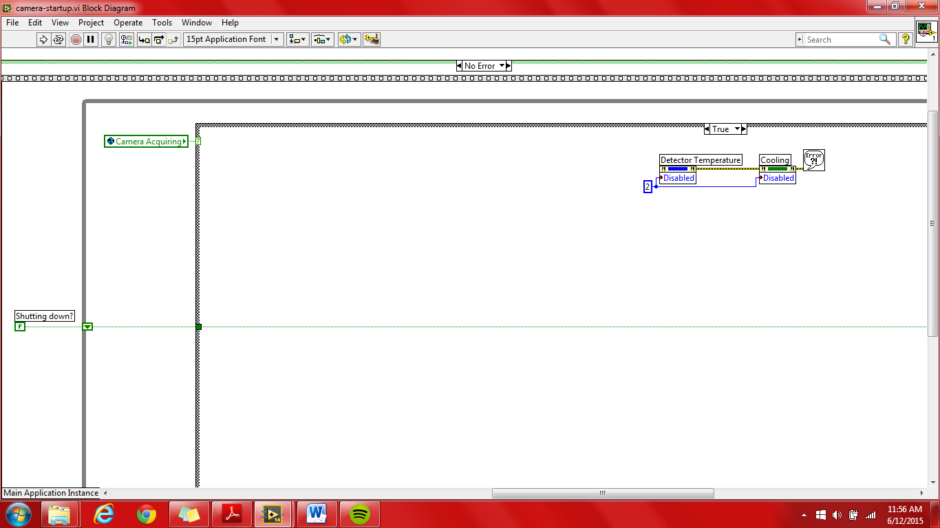

In the above figure:

The figure above shows the case structure if the camera is currently acquiring. If the camera is currently acquiring, then the detector temperature graph and cooling status are disabled.

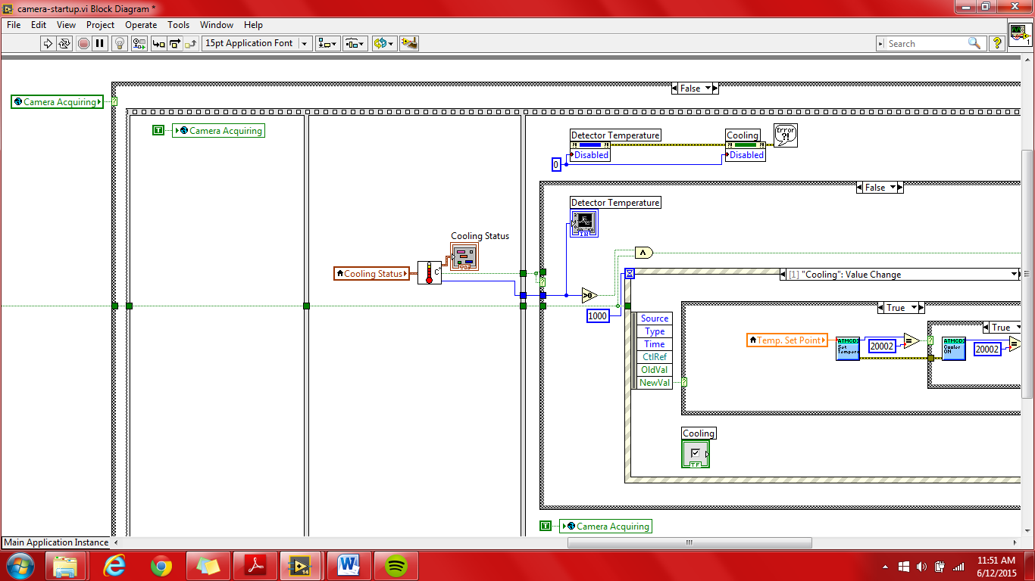

In the above figure:

The current cooling status is input into the *get camera temperature – subvi.vi* where the current temperature and cooling status are output. A Boolean indicating if an error occurred is also an output.

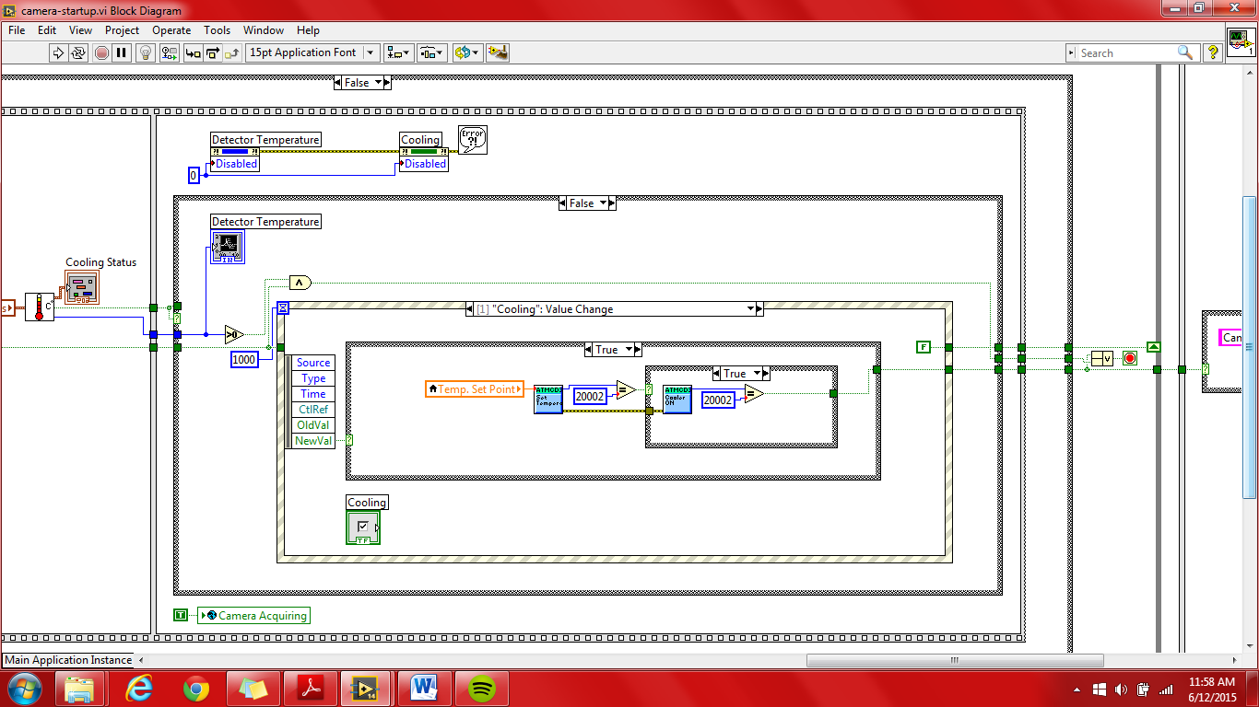

In the above figure:

This inner case structure controls the display on its front panel as well as setting the temperature of the Andor Camera via the event structure. The event structure accounts for the following:

* Timeout
* Cooling Value Change
* Temp. Set Point Value Change
* Warm up CCD and Turn Off Camera Value Change

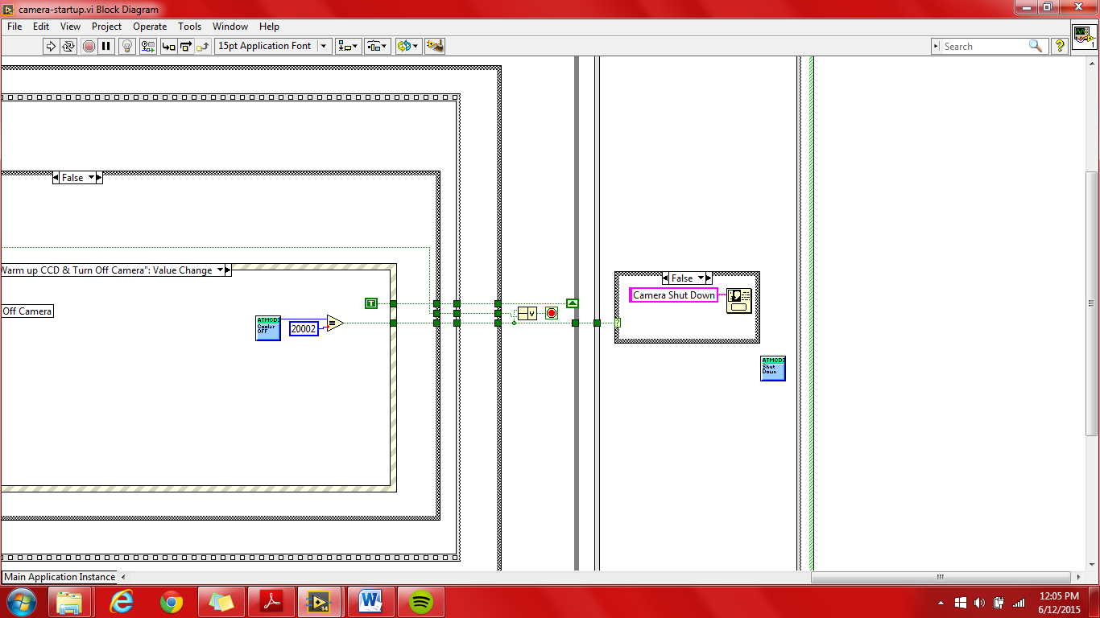

In the above figure:

The user is shown a message upon the termination of the VI, depending on if an error occurred or shut down was successful. The Shut Down.vi shuts down the camera.

**Autofocus-view-calibration.vi**

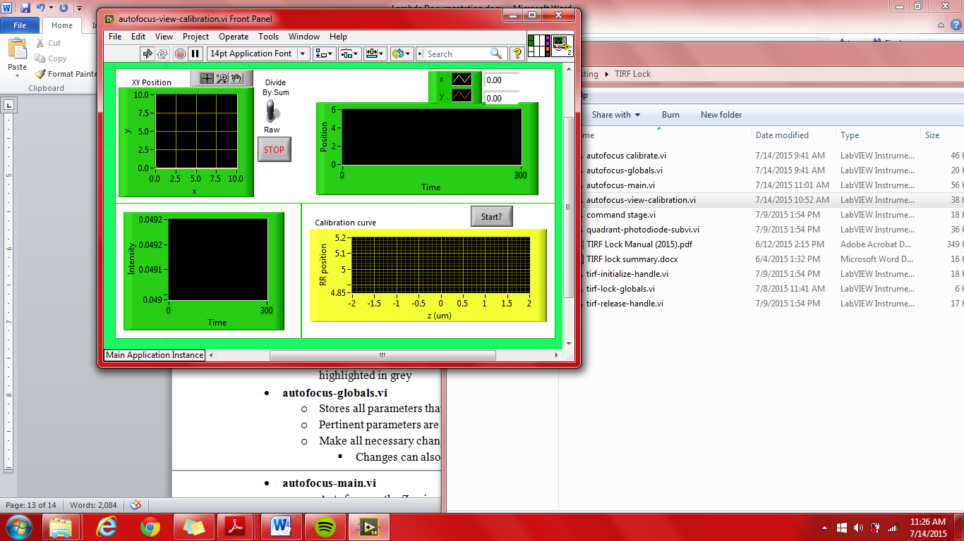

The purpose of this VI is to allow the user to view the current X & Y positions of the quadrant photodiodes (QPD) of the total internal reflection fluorescence (TIRF) lock in addition to the intensity, or power, of the beam saturating the QPD. On the front panel, as seen above, there is a plot for the current beam location in X vs Y and another plot to show the positions of X & Y over time. The user can then set a calibration curve corresponding to the settings made in autofocus-globals.vi. This calibration curve is then used to run the autofocus-main.vi.

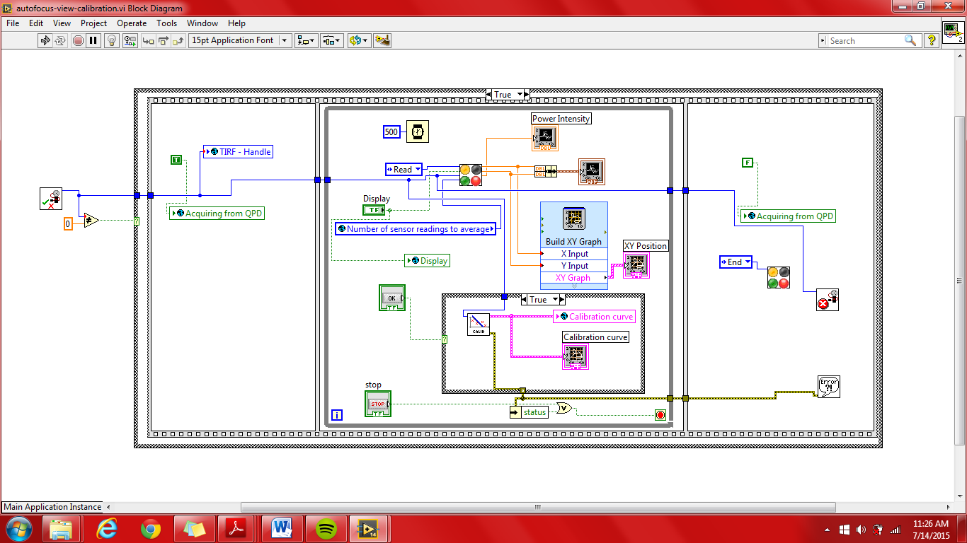

SubVI’s:

* **autofocus-calibrate.vi**
  + Creates a calibration curve for delta Z, dependent on either X/Y axis
  + Parameters are changed using autofocus-globals.vi where pertinent parameters are highlighted in grey
* **autofocus-globals.vi**
  + Stores all parameters that are used to perform autofocuses and calibrations
  + Pertinent parameters are highlighted in grey
  + Make all necessary changes here prior to any calibration/autofocus
    - Changes can also be done while running autofocus-view-calibration.vi
* **autofocus-main.vi**
  + Autofocuses the Z axis according to current calibration curve
  + Parameters are changed using autofocus-globals.vi where pertinent parameters are highlighted in grey
  + Runs separately from autofocus-view calibration, however, this VI relies on an existing calibration curve for autofocusing
* **command stage.vi**
  + Broadcasts changes to the Z axis of the nano-positioner/stage to stage-controller.vi
* **quadrant-photodiode-subvi.vi**
  + Returns the current X & Y of the QPD as well as the sum of these values
  + Using the constants found in tirf-lock-globals.vi, beam power/intensity is calculated for each data point.
* **tirf-lock VI’s**
  + tirf-initialize-handle.vi
    - Initializes tirf-lock
    - Returned value is stored in tirf-lock-globals.vi to allow the user to run autofocus-main.vi without running-view-calibration.vi
  + tirf-lock-globals.vi
    - Majority of the numeric controls may be ignored here as they were intended to be used with DAQ when communicating with TIRF-Lock.
    - Only transimpedence gain, peak responsivity, and divde by sum/raw will have an effect on data interpretation.
  + tirf-release-handle.vi
    - Releases TIRF’s handle